

System Requirements Report

Rash Driving Detection and Alert System Using Computer Vision

Sedem Quame Amekpewu 10622243

Samuel Kobina Andam Obeng 10627711

Supervisor : Dr. Nii Longdon Sowah

30th October, 2019

Table of Contents

Introduction 1

Purpose 1

Intended Audience 1

Project Scope 2

Definitions and Acronyms 2

References 2

Overall description 2

User Needs 2

Operating Environment 3

Design and Implementation Constraints 3

Assumptions and Dependencies 3

System features 4

Functional Requirements 4

Nonfunctional Requirements 5

External Interface Requirements 5

System Features 6

# Introduction

### Purpose

The purpose of this document, is to state the needed building blocks that would be needed for successfully implementation, of a rash driving detection system, that could reduce the occurrence of road accidents.

### Intended Audience

The project will be a prototype of a rash driving detection system, which would be implemented and used on the college premises. The project is supervised by lecturers in the college of engineering science.

### Project Scope

The purpose of the rash driving detection system is to successfully detect road safety violators and immediately inform road safety authorithies. The system is based on using computer vision techniques to successfully detect, cars and their metadata at specific instances of time, and transmitting the captured information to an external server. We will machine learning algorithms to detect certain actions such as lane jumping. Above all, we hope to reduce the number of accidents that occur on Ghanaian roads.

### Definitions and Acronyms

|  |  |
| --- | --- |
| Abbreviation | Meaning |
|  |  |
|  |  |

### References

# Overall description

### User Needs

Users of the system, should be able to query and get any information captured, by the remote hardware device. Below are functions that respective users will be able to make.

1. Administrator
   1. Watch a live stream of the roads on which the cameras are positioned.
   2. See all flagged vehicles, and query the captured information.
   3. Get road analytics.
   4. See respective vehicle results.
   5. Add and remove workers to the system.
2. Workers
   1. Watch a live stream of the roads on which the cameras are positioned.
   2. See all flagged vehicles, and query the captured information.
   3. Get road analytics.
   4. See respective vehicle results.

### Operating Environment

The operating environment of the rash driving detection system is listed below.

1. Database system created using Postgres SQl
2. Client/ Server System
3. Operating System: Linux Os, Windows Os
4. Platform: Python, Artificial Intelligence (Ai), Machine Learning (ML), Computer Vision (openCV)

### Design and Implementation Constraints

1. Database, must be centralized and hosted on an external server.
2. Image and Video Processing must be done on the raspberry pi.
3. Captured data, must be stored, on the raspberry pi, and exported to the webserver in real time and then deleted immediately.
4. The raspberry pi should have, a stable internet connection.
5. The server should, have a script to sanitize input into the database.
6. The user interface, should be able to retrieve data from stored in the database and on the raspberry pi.

### Assumptions and Dependencies

This section, describes the various assumptions that were made, when creating the system.

1. The system, will only be interfacing with one camera.
2. Details of violators that are of concern to authorities include the vehicle registration number, vehicle color, vehicle model, vehicle speed.

In creation of the system, we assumed that data flow, will be unidirectional (from the raspberry pi, to the server, to the client program.)

# System features

This section, describes the components of the system, and how these components would be able to perform their functions.

The system, captures information from the cameras when any vehicle on the road triggers an action (speeding or lane jumping).

This project, has a high priority because, it has the potential of reducing the number of casualties that result from the occurrence of accidents.

1. Stimulus/Response Sequences
   1. An event is triggered, when a car exceeds the speeding limit.
   2. The camera captures car metadata such as the car’s number plate, car color, brand etc.
   3. Captured data is preprocessed instantenously, and stored.
   4. The stored data, is exported onto the external server, and then deleted from the raspberry pi, to save resources.
   5. The server, processes the received data into an acceptable format, before storing the received data.
   6. System users, can query the system to obtain stored information from the database concerning past violators.
   7. System users, can also change the mood of the camera from survelliance to streaming.

### Functional Requirements

This section describes the various, system features that must be included for the system to work successfully.

1. Embedded Systems

The term embedded system, describes the raspberry pi, that is responsible for detecting and capturing information, and performing pre-processing checks on data received from the system.

1. Centralized database

The centralized database, describes a hosted database that is responsible for storing pre-processed data, received from the raspberry pi, in a transparent manner such that data is not tempered with and returns data quickly when queried from the ui.

1. Server System

This term refers primarily to an architecture, holds the database and preprocessing scripts to perform additional filtering on received data before inserting them into the database.

1. Client System

This system is responsible for generating the UI, which would be interacted with by users of the system to get various information.

### Nonfunctional Requirements

This section describes various criteria that can be used to judge the operation of a system, rather any of it’s specific behaviors.

1. Database Normalization

The database, used must reduce the amount of redundant data, by organizing data in a very efficient manner, such that queried data is provided so fast, that the user does not experience and form of lagging.

1. Security

The system, must pre-process, all received data to make sure that malicious characters do not manipulate the system over a network or through its cameras.

1. Intuitive User Interface

The user interface must be intuitive, and must not require a large degree of experimentation to be familiar with.

1. Software Quality Attributes
   1. Accuracy: The system, must accurately detect the speed of any given vehicle and must appropriately record the vehicle’s data.
   2. Limited Lags: The system must operate without lagging.
   3. Robust: The system must, be able to tolerate some degree of fault and still work efficiently under such conditions.
   4. Secure: The system should, protect user data.
   5. Transparent: The system, should prevent data from being altered without prior permission.

### External Interface Requirements

This section describes the various, interfaces that would be used by the various sub-systems to perform the various functions.

1. Client System (User Interface)
   1. Languages: Python, SQL/NoSQL, Java
   2. Libraries: Open Computer Vision (OpenCV), Plate Recognizer
   3. Front-End:
   4. Back-End:
2. Hardware Interface
   1. Raspberry Pi
   2. Linux Os
   3. Raspberry Pi NoIR Camera
3. Software Interfaces
   1. Operating System (Windows, Linux OS)
   2. Latest Browser (Google Chrome, Firefox, etc.)
   3. IDE or Code Editors (Vs Code, Vim)
4. Communication Interfaces
   1. Raspberry Pi’s ip address
   2. Stable internet
   3. SSH (raspberry pi, command line access of the Pi from another computer)
   4. VNC (remote access to the Pi’s graphical interface, viewed in a window on another pc)
   5. SFTP (used for copying files between the raspberry pi and server computer)
   6. Rsync (used for file or folder synchronization between Pi and another computer primarily done over SSH)

### System Features

1. UI Mock Ups
   1. Login Page

Page that users would use to log into the system.

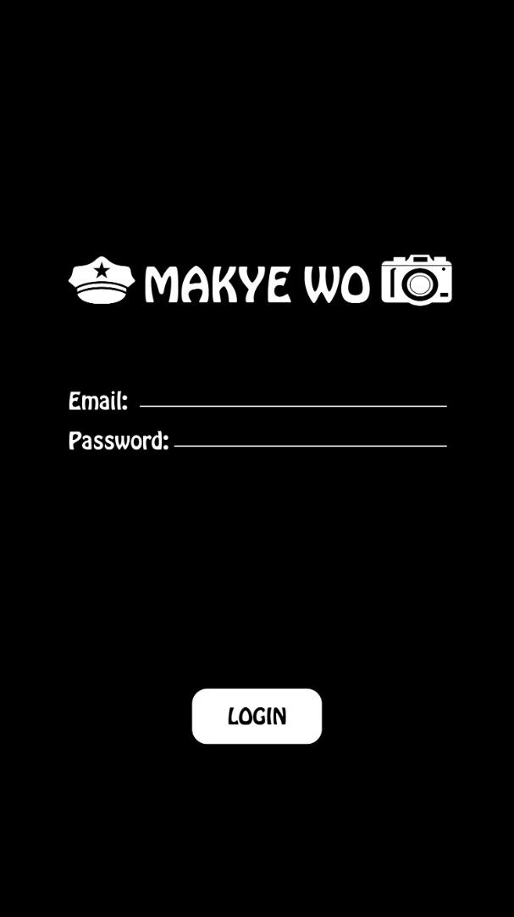

* 1. Loading Page



* 1. Dashboard

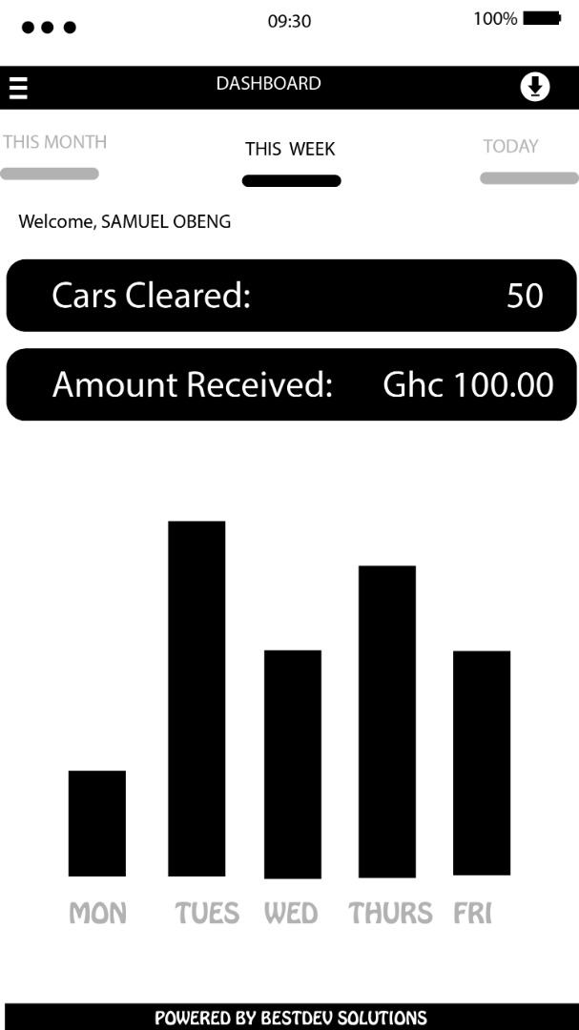

* 1. Debt Clearance

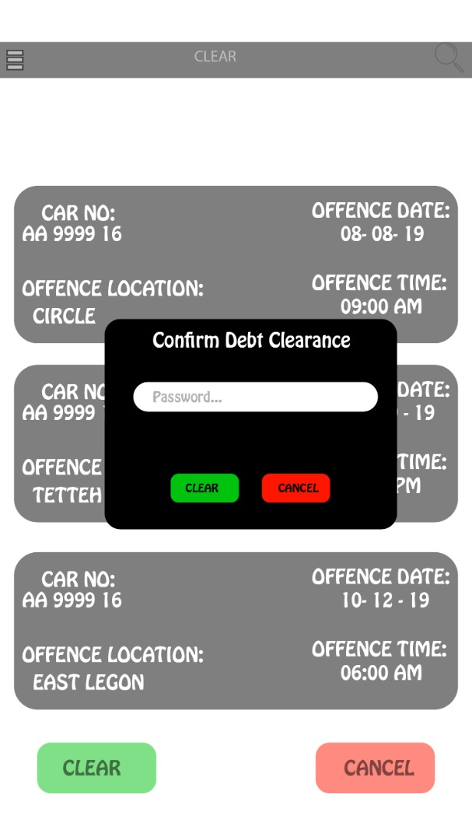

* 1. Violator List

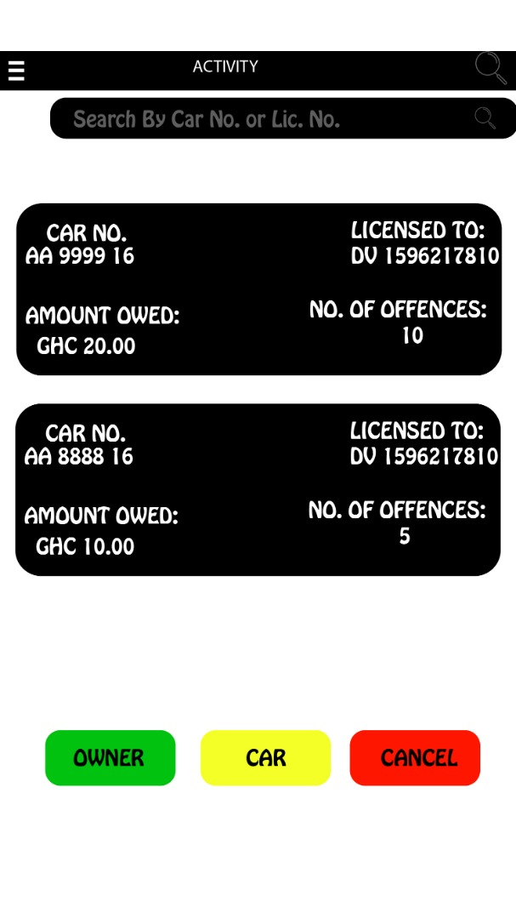

1. Site map

This diagram, represents how the various pages will be linked in the application.

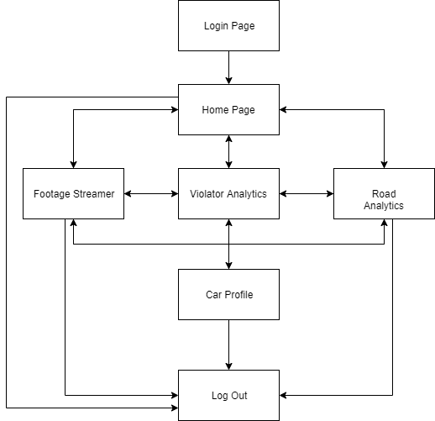

1. Architecture
2. Flow Diagrams